The NYC Community Air Survey Findings Between 2009 and 2017 showed that the annual average levels of fine particulate matter (PM 2.5), Nitrogen Dioxide (NO2), Nitric oxide (NOx) and black carbon have declined 30%, 26%, 44% and 30%, respectively. (NYC.gov, 2019). More up to date data shows they have continued to fall with slight increases in PM2.5 and Black Carbon after the NYC Pause due to Covid-19

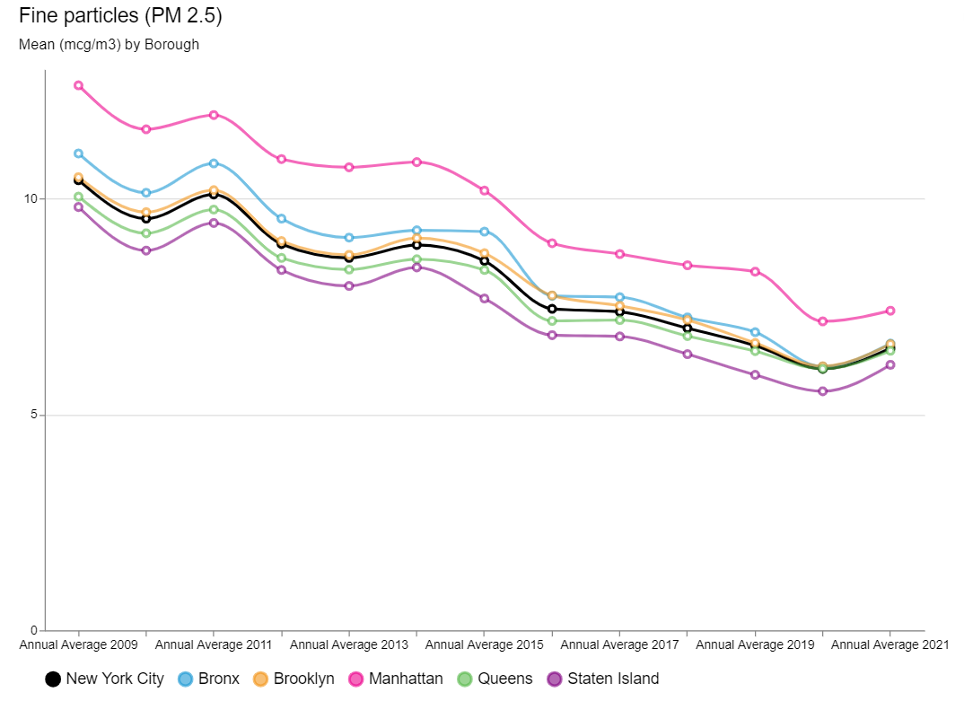

Figure 1 PM2.5 (NYC.Gov, 2023)

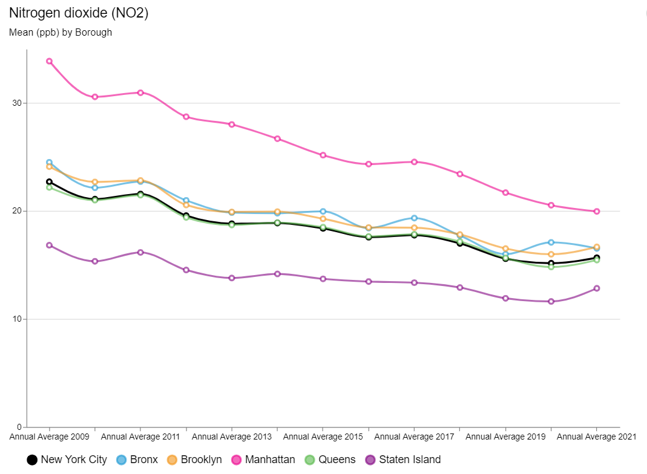

Figure 2 Nitrogen Dioxide (NYC.Gov, 2023)

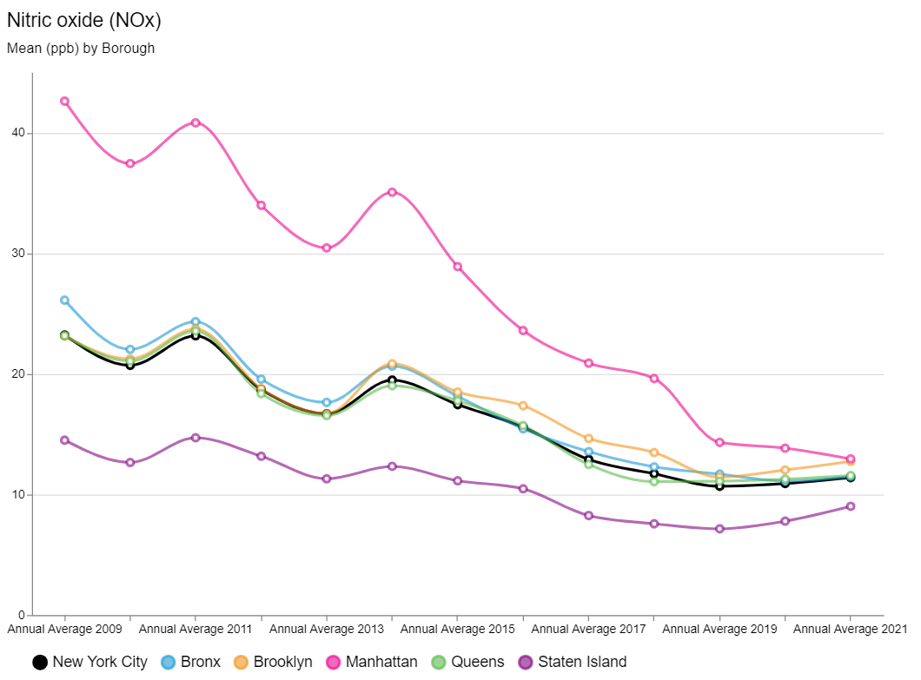

Figure 3 Nitric Oxide (NYC.Gov, 2023)

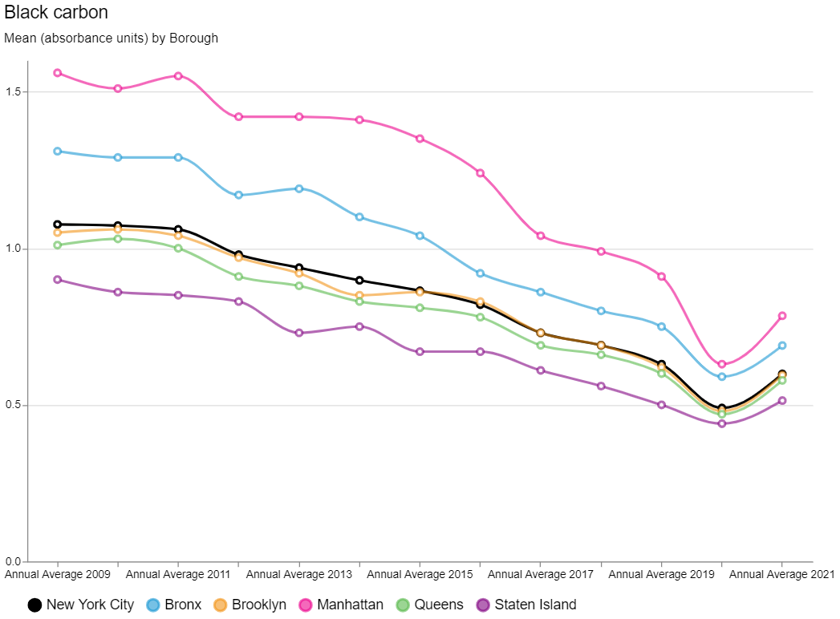

Figure 4 Black Carbon (NYC.Gov, 2023)

The largest declines have been observed for Sulphur Dioxide (SO2), due largely to an implementation of heating oil regulations. As of July 2015, there were no more permits issued for the use of the #6 fuel oil, a heavy burner oil used primarily for maritime and oil-fired heating systems. All boilers had to switch to gas or less harmful oils #2 or #4. With targeted enforcement and support approximately 90% of boilers had been converted over from #6 oil. (NYC, 2018)

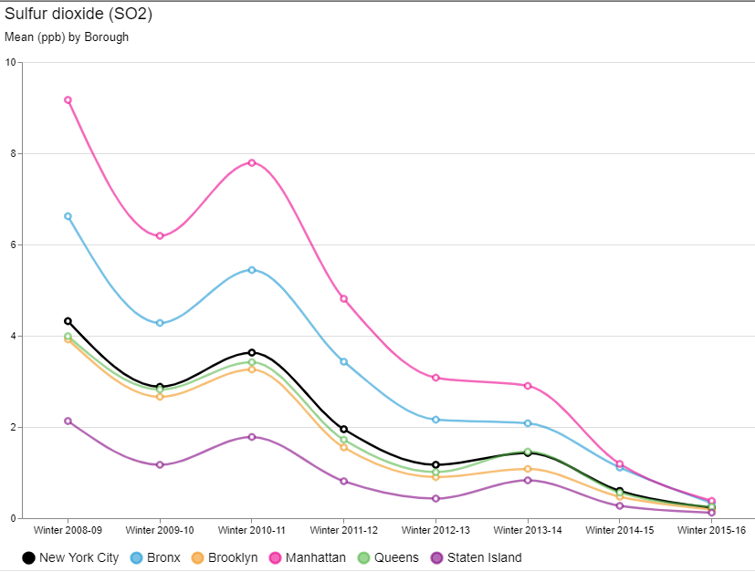

Figure 5 Sulphur Dioxide (NYC.Gov, 2023)

The overall average ozone levels have remained stable.

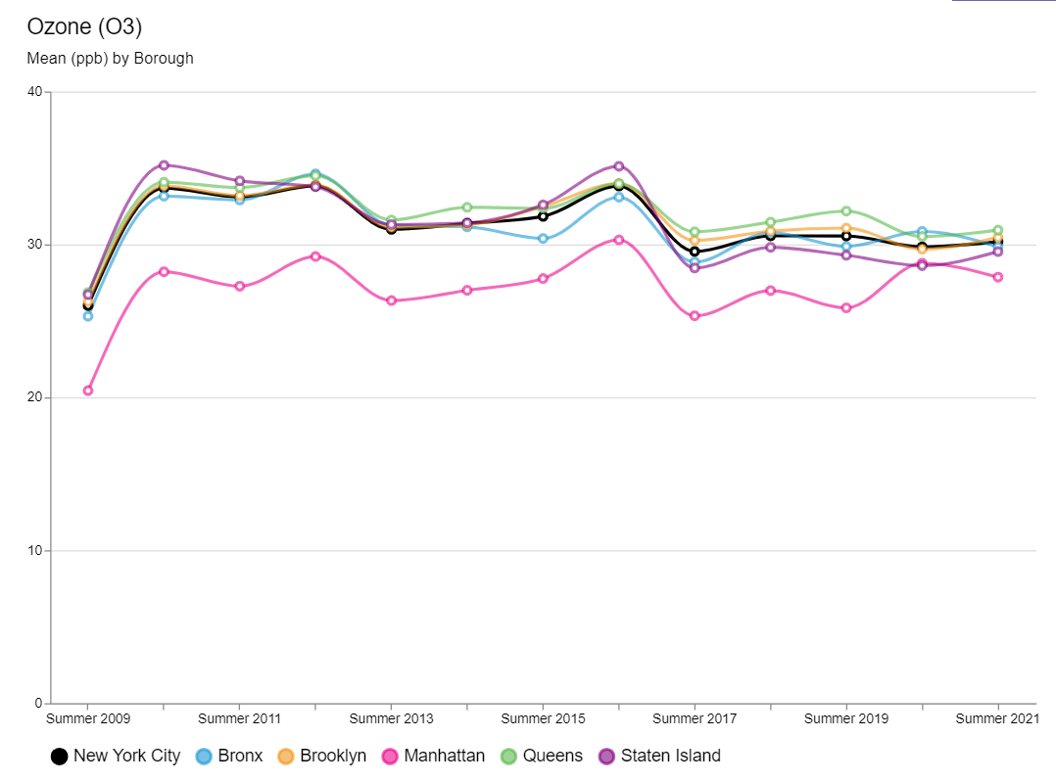

Figure 6 Ozone (NYC.Gov, 2023)

# Works Cited

NYC.gov, 2019. *NYC.gov.* [Online]   
Available at: https://www.nyc.gov/site/doh/about/press/pr2019/health-department-releases-report-on-air-quality.page  
[Accessed 05 May 2023].

NYC.Gov, 2023. *Environment and Health Data Portal.* [Online]   
Available at: https://a816-dohbesp.nyc.gov/IndicatorPublic/beta/data-explorer/air-quality/  
[Accessed 5 May 2023].

NYC, 2., 2018. *One New York: The Plan for a Strong and Just City.,* New York: City of New York Mayors Office.